NNF

Optimize for all 7 parameters: {delta, Amax, Vmax, Ka, alpha, Km, beta_max}

1. Relative amp of Ptot > 0.25

2. max(Ptot) is minimized s.t Kd is maximized

~~3. BMAL (At) average level matches SNF model~~

4. Relative amp of BMAL > 0.2

~~5. Period of Ptot matches SNF~~

6. max(Rev) < 10 (max(Ror)<5 for PNF)

Method: simulated annealing

Options: 'TemperatureFcn','temperatureboltz', 'AnnealingFcn','annealingboltz',

Cost function:

penalty = 10;

cost_item = [penalty*(BMAL_amp./BMAL_amp_sim+(BMAL_amp_sim/BMAL_amp-1)^2)*(BMAL_amp_sim < BMAL_amp)+0.01; ...% amp>0.2

penalty*(maxRev_sim/Rev_max-1)^2*(maxRev_sim > Rev_max)+0.01; ... % max(Rev)<10

Ptot_max_sim/max_Ptot_SNF; ... % minimize max(Ptot)

penalty*(Ptot_amp/Ptot_amp_sim+(Ptot_amp_sim/Ptot_amp-1)^2)*(Ptot_amp_sim < Ptot_amp)+0.01]; % amp > 0.25

cost = sum(cost_item);

Results of 128 runs (‘NNF_fit_batch.mat’):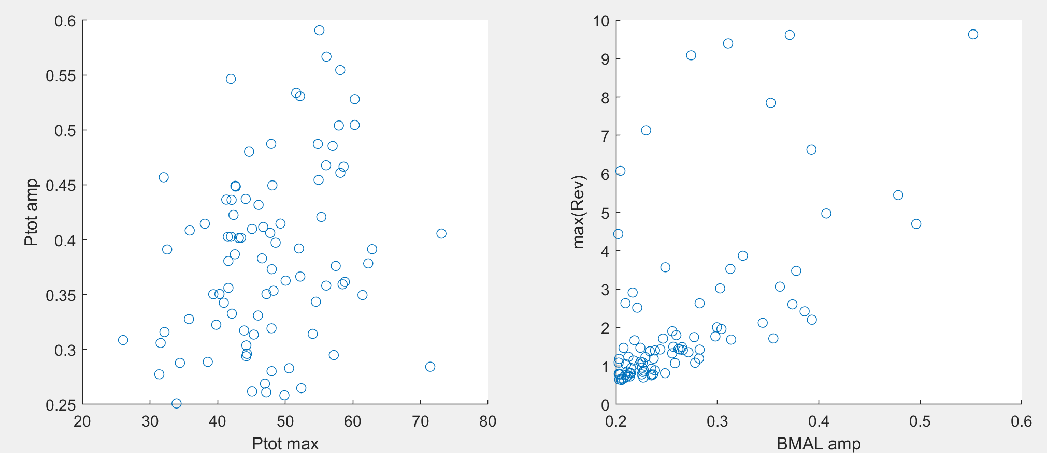

Best set:

[delta, AMAX, VMAX, KA, alpha, Km, beta_max]= [0.3173 9.9232 9.8926 2.5433 12.7306 1.1993 3.0514]

Ptot_max_sim = 26.0253

Ptot_amp_sim = 0.3086

BMAL_amp_sim = 0.2165

maxRev_sim = 2.9117

cost = 0.3770

cost_item = [0.0100, 0.0100, 0.3470, 0.0100]

SNF

Optimize for all 5 parameters: {At, Ka, alpha, Km, beta_max}

1. Relative amp of Ptot > 0.25

2. max(Ptot) is minimized s.t Kd is maximized

Method 1: simulated annealing,

Options: 'TemperatureFcn','temperatureboltz', 'AnnealingFcn','annealingboltz'

Cost function:

penalty = 1;

cost_item = [Ptot_max_sim/max_Ptot_SNF; ... % minimize max(Ptot)

penalty*((Ptot_amp/Ptot_amp_sim+(Ptot_amp_sim/Ptot_amp-1)^2)*(Ptot_amp_sim < Ptot_amp)+1*(Ptot_amp_sim >= Ptot_amp))]; % amp > 0.25

cost = sum(cost_item);

Results for 128 runs:

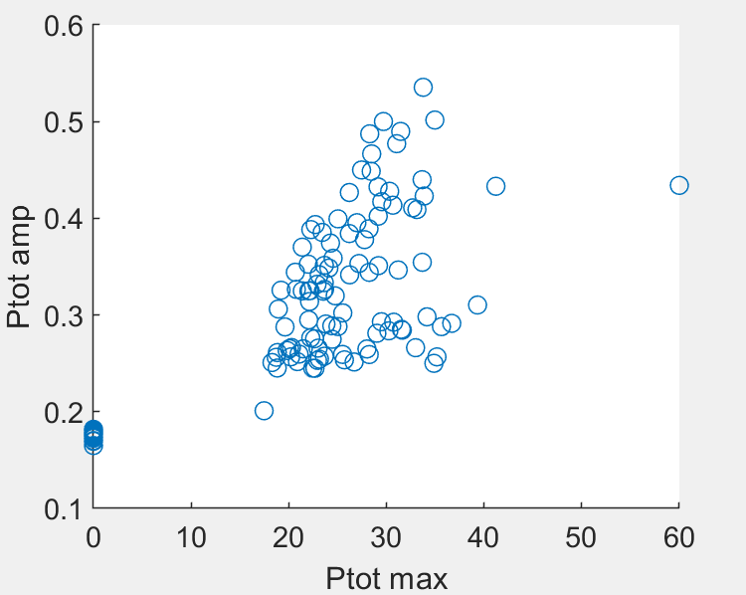

Best fit set:

[At, KA, alpha, Km, beta_max] = [3.6335 1.2782 5.4937 1.0040 2.5484]

Ptot_max_sim = 18.2958

Ptot_amp_sim = 0.2508

cost = 1.2439

cost_item = [0.2439 1.0000];

Method 2: Genetic algorithm multiobjective

cost_item = [Ptot_max_sim; ... % minimize max(Ptot)

-Ptot_amp_sim]; % maximize Ptot amp

Pareto front:

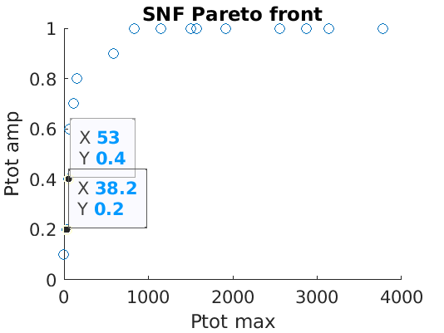

Remarks: This algorithm does not generate results better than simulated annealing, but clearly shows that small Ptot_max incurs small Ptot_amp.